**Advanced Software Engineering**

**Increment #3**

**By**

**Goutham Marikanti(Class Id: 22)**

**Jeevana Tunuguntla(Class Id: 41)**

**Rakesh Vistarakula(Class Id: 46)**

**Saitejasree Ramala (Class Id: 51)**

**Import Existing Services/API**

Google Maps API

Login service

Employee Login Web service

Employee details Web service

Google Maps Web Service

Call Web Service

Email Web Service

**Detail Design of Services**

WSDL: Service description

In this application, the employee login with his/her SSO details into the site and then there will be different features like displaying location, donating food, clothes and money and also if there are any health campaigns which describes the category of the food i.e. if the food comes under the category of American food, Indian food, etc and the other feature like donating food or clothes which helps in donating food or clothes of whatever they can afford and also other feature like contact us which helps the hotels or restaurants to contact when they can donate food or clothes and the other ‘Feedback’ in which either the hotels/restaurants or the code NGO’s can give their feedback on the service provided and the other feature like the ‘Google Maps’ in which either the NGO’s go or the hotels/restaurants come to give food or clothes.

Sequence diagram (using Visio)

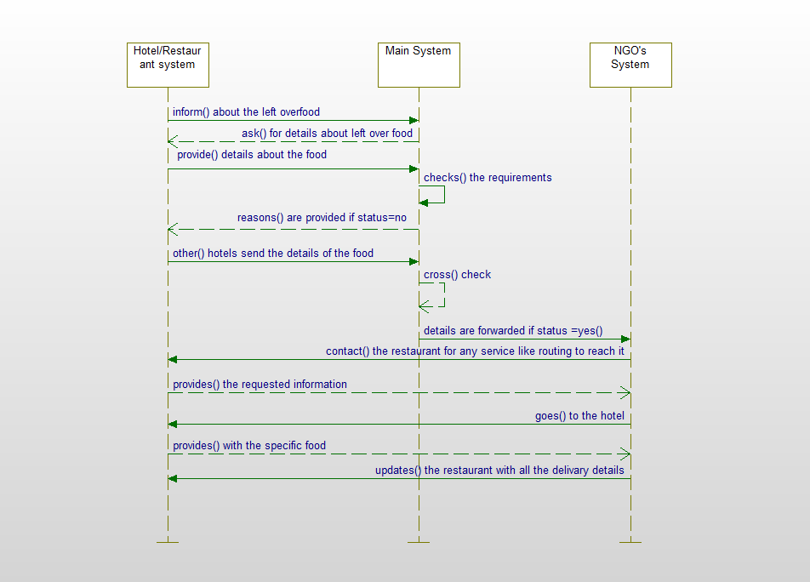

Class diagram (using Visio)

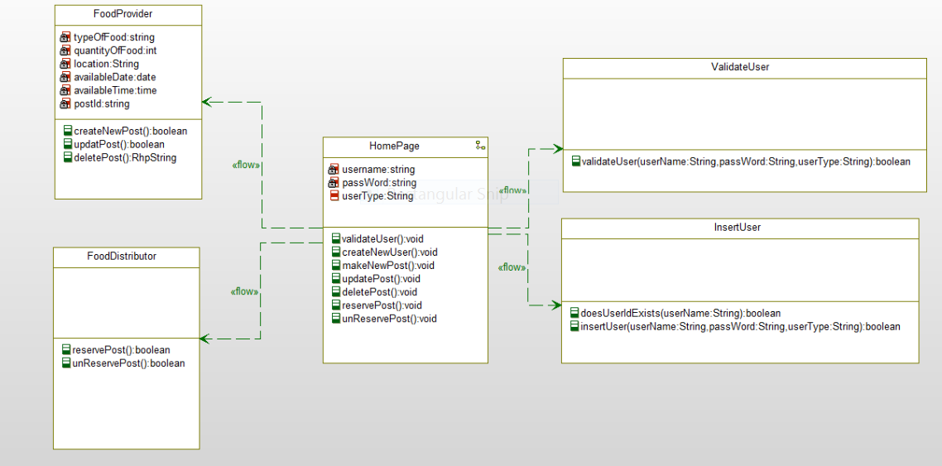

Design of Mobile Client Interface

In this application, the employee login with his/her SSO details into the site and then there will be different features like displaying location, donating food, clothes and money and also if there are any health campaigns which describes the category of the food i.e. if the food comes under the category of American food, Indian food, etc and the other feature like donating food or clothes which helps in donating food or clothes of whatever they can afford and also other feature like contact us which helps the hotels or restaurants to contact when they can donate food or clothes and the other ‘Feedback’ in which either the hotels/restaurants or the code NGO’s can give their feedback on the service provided and the other feature like the ‘Google Maps’ in which either the NGO’s go or the hotels/restaurants come to give food or clothes.

We made use of Google Maps, Call, Email, Employee Login and Employee details web services

**Implementation**

Implementation of services

Google Maps Web Service

Call Web Service

Email Web Service

Employee Login Web Service

Employee details Web Service

Implementation of user interface (Mobile Apps)

In this application, the employee login with his/her SSO details into the site and then there will be different features like displaying location, donating food, clothes and money and also if there are any health campaigns which describes the category of the food i.e. if the food comes under the category of American food, Indian food, etc and the other feature like donating food or clothes which helps in donating food or clothes of whatever they can afford and also other feature like contact us which helps the hotels or restaurants to contact when they can donate food or clothes and the other ‘Feedback’ in which either the hotels/restaurants or the code NGO’s can give their feedback on the service provided and the other feature like the ‘Google Maps’ in which either the NGO’s go or the hotels/restaurants come to give food or clothes.

**Deployment**:

Include your project ScrumDo link to the report

[http://www.scrumdo.com/projects/project/ase-fall-2014-umkc- project1/iteration/111373](http://www.scrumdo.com/projects/project/ase-fall-2014-umkc-%20%20%20%20%20%20%20%20%20project1/iteration/111373)

Github URL

[**https://github.com/jeeju/CS551_ASEChallenge2/**](https://github.com/jeeju/CS551_ASEChallenge2/)

Screenshots and explanation on the design, implementation and testing.

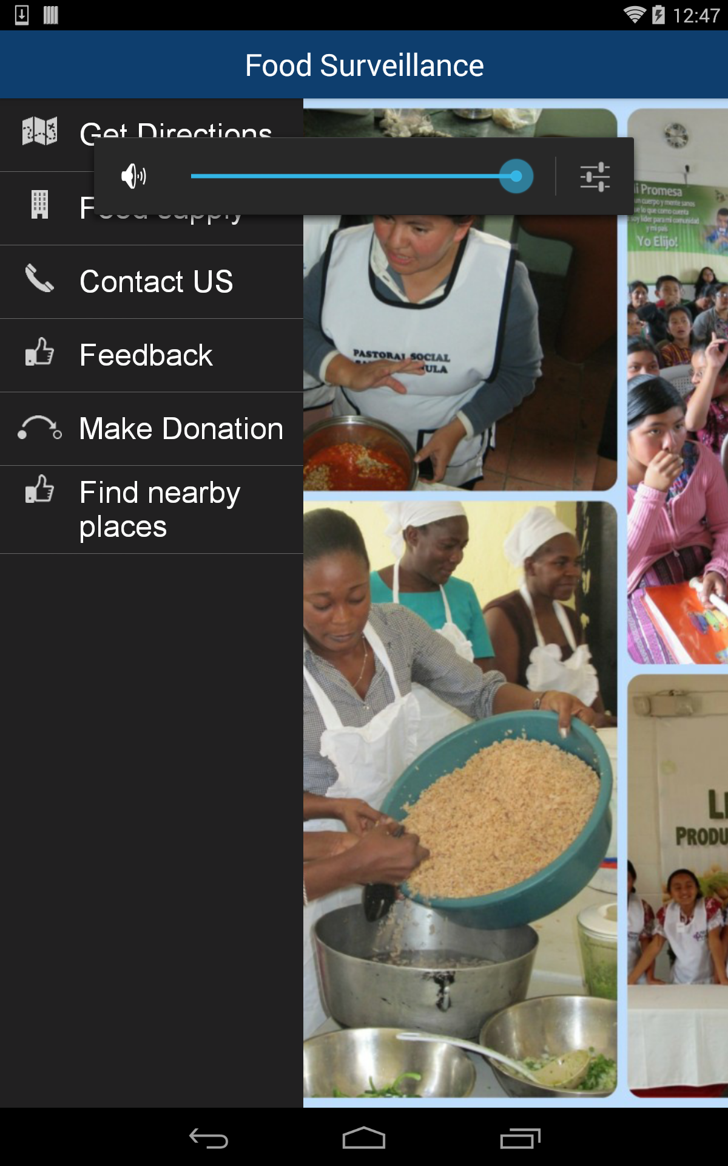

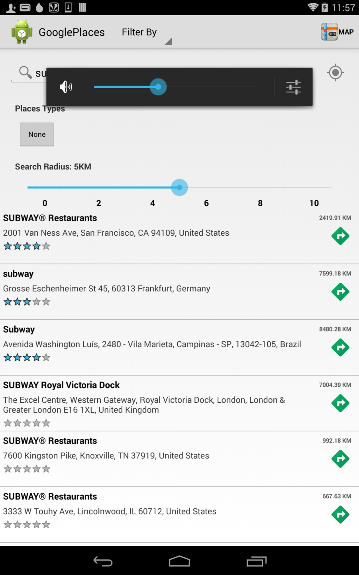

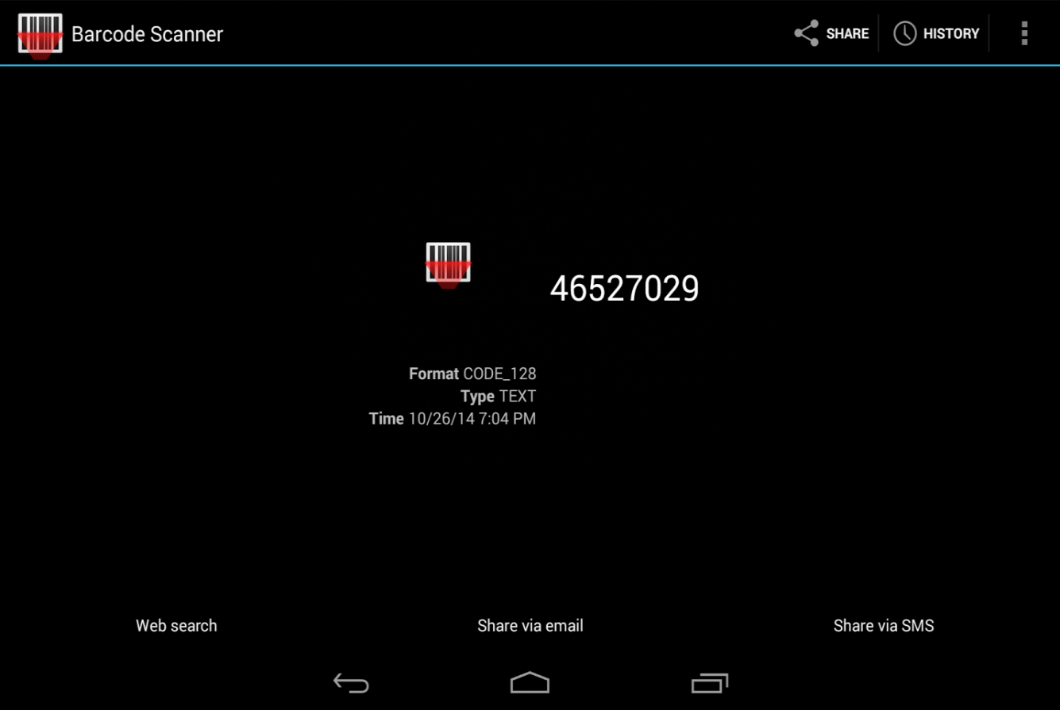

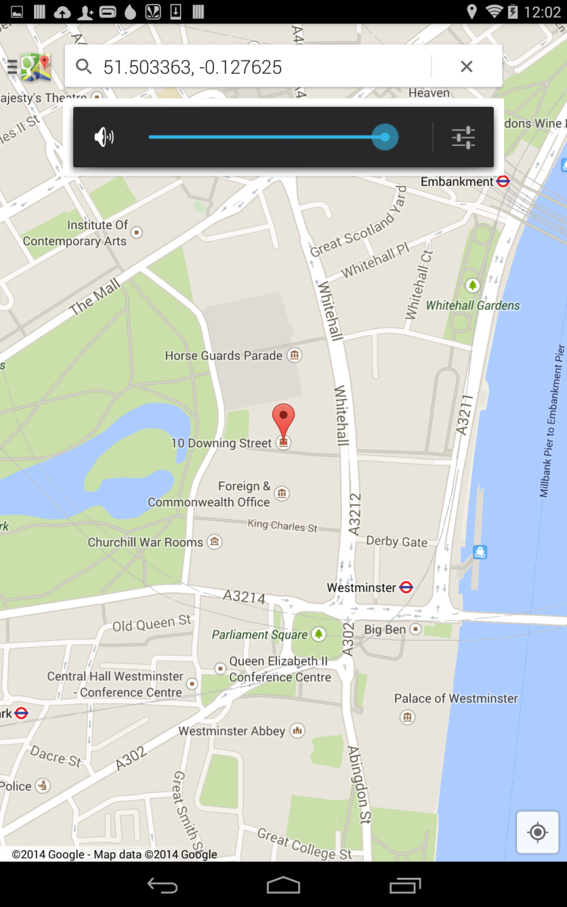

Our own data model includes calling the Google Maps web service for providing location help service to the restaurants/hotels and to NGO’s and helping the NGO’s to search according to their requirements like the kind of food they need. Providing the restaurants or NGO’s to help us by giving their feedback of what is good and what needs to be improved and also contacting us for any of the service necessary for them in their order and also providing with the places according to their search.

**Project Management**:

* <http://www.scrumdo.com/projects/project/ase-fall-2014-umkc-project1/iteration/111373>

Implementation status report

* + - Work completed:
      * Description

Completed almost half of the project and we are trying to add the remaining during the third increment to our project.

* + - * Responsibility (Task, Person)

Jeevana: Did all the Android part

Goutham: SQL related part

Rakesh: Web services part

Saitejasree: API’s part.

* + - * Time taken (#hours)

Took about 20 hours.

* + - * Contributions (members/percentage)

Jeevana: 25%

Goutham: 25%

Rakesh: 25%

Saitejasree: 25%

* + - Work to be completed
      * Description

We should add the other services that are required for our project and are planning to get a clear idea of what are the modifications to be done and add them during the third increment.

* + - * Responsibility (Task, Person)

Jeevana: Android part

Goutham: SQL related part

Rakesh: Web services part

Saitejasree: API’s part

Issues/Concerns